# **ABSTRACT**

This initiative introduces a deep learning-driven system designed to detect and classify brain tumors from MRI scans, meeting the urgent demand for precise and effective diagnostic tools in the medical field. Utilizing an enhanced convolutional neural network (CNN) architecture with transfer learning, the system was trained to recognize and categorize gliomas, meningiomas, pituitary tumors, and cases without tumors. The model demonstrated high accuracy, precision, recall, and F1 scores across all categories, proving its dependability in tumor detection. To enhance model generalization and reduce overfitting, advanced image preprocessing methods and data augmentation techniques were employed. Additionally, the system includes an intuitive web-based interface that allows clinicians to upload MRI images, review findings, and create automated diagnostic reports. Despite facing challenges like limited datasets, substantial computational resource needs, and initial integration complications, the project succeeded in developing a resilient solution for brain tumor detection. Future improvements will aim at expanding the dataset, enhancing real-time processing capabilities, and incorporating explainable AI methods to build greater confidence among healthcare professionals. This system holds the potential to significantly improve diagnostic accuracy and efficiency in clinical environments.

# **CHAPTER 1**

# **INTRODUCTION**

* 1. **Overview**

Brain tumors develop from unchecked cell proliferation, resulting in abnormal mass formations that can disrupt normal brain functions and damage healthy tissue. These tumors are classified as either benign (low-grade), which grow slowly and remain localized, or malignant (high-grade), which are aggressive, proliferate rapidly, and may spread to other areas. MRI of the brain is a vital imaging technique for identifying tumors due to its high resolution and ability to provide detailed information about brain structures. There has been a rise in automated methods for tumor detection and classification using MRI, with Support Vector Machines (SVM) and Neural Networks (NN) being commonly employed in the past. Recently, deep learning models have emerged as a more efficient alternative, capable of capturing complex data relationships with fewer nodes compared to traditional architectures like SVM or K-nearest neighbors (KNN). Consequently, deep learning has become a leading approach in the domain of medical image analysis and other health informatics fields, significantly improving the prospects for detecting and diagnosing brain tumors.

**1.2 Background and Motivation**

The brain serves as the main control center of the body, and numerous brain disorders have been identified in recent years. The tools used for diagnosing brain diseases are becoming increasingly complex and are a major area of focus for ongoing research; however, the application of AI in identifying brain disorders has enhanced the precision and dependability of disease detection and forecasting. Automated methods for analyzing brain images non-invasively have become essential, considering that brain diseases can be life-threatening and significantly contribute to mortality rates in advanced nations. The use of AI in surgical procedures for brain tumors can lead to safer and more effective treatment results. A significant challenge remains in the knowledge gap between healthcare practitioners and data science specialists. This project arises from the need for a tool that can aid radiologists in detecting brain tumors with improved accuracy and efficiency, ultimately resulting in better patient outcomes.

**1.3 Statement of the Problem**

The problem statement for this study highlights several crucial challenges related to brain tumor detection using MRI scans. First, the accuracy of identifying brain tumors is adversely affected by the reliance on physicians to manually locate them, leading to inefficiencies and reduced precision. Additionally, the segmentation of tumors is particularly challenging due to the complex structure of brain anatomy, which makes it difficult to accurately outline tumor boundaries. Ultimately, the primary challenge lies in recognizing brain tumors amidst differences in their location, shape, size, and intensity in different patients, coupled with the often vague and irregular edges of the tumors. Together, these factors underscore the urgent need for advanced automated solutions to enhance diagnostic accuracy and efficiency in clinical practice.

**1.4 Aim and Objectives**

**Aims**

The aim of this project is to develop an automated system for the accurate detection and classification of brain tumors using MRI images.

**Objectives**

1. To create a deep learning model capable of classifying brain tumors as glioma, meningioma, pituitary, or determining the absence of a tumor.
2. To evaluate the model's performance using metrics such as accuracy, precision, recall, F1-score, and the confusion matrix.
3. To design an intuitive web interface that enables clinicians to upload images and view the results.

**1.5 Significance of the Project**

Identifying brain tumors is vital in medical diagnostics because of the serious risks these conditions can pose to patients' health and overall well-being. These tumors present a significant challenge due to their widespread connections with neurons and surrounding tissues, rendering the brain vulnerable to various diseases. Characterized by abnormal cell proliferation within brain tissue, these tumors can affect individuals of any age or background and exhibit various types, ranging from benign to malignant. Since brain tumors can disrupt neurological functions and lead to symptoms such as headaches, seizures, cognitive decline, and potentially life-threatening issues, swift and accurate detection is critical. Additionally, the timing of the diagnosis plays a key role in influencing the prognosis and available treatment options for those diagnosed with brain tumors. Early detection enhances the likelihood of successful treatment results, allowing healthcare providers to implement strategies focused on preserving quality of life and cognitive abilities.

**1.6 Project Risks Assessment**

The potential risks associated with this project include:

*Table 1.1 Risks Assessment*

|  |  |
| --- | --- |
| **Risks** | **Mitigation Strategy** |
| The model may be trained and perform poorly due to the lack of full quality MRI image datasets available | Utilize public datasets and augment to increase size and diversity. |
| The model has the risk of not achieving the desired accuracy. Missed tumours or incorrect detection of tumours may cause low accuracy | Optimize model architecture and use data augmentation and hyper parameter tuning. |
| Limited computational resources | Access higher capacity computer |

**1.7 Project Organization**

This document aims to summarize the activities and processes that were integral to the design and execution of this project. The subsequent chapters will discuss the specific topics outlined below:

Chapter 2: Literature Review - This portion evaluates relevant research concerning the Detection of Brain Tumors using machine learning techniques.

Chapter 3: Methodology - This chapter will describe the tools, methods, and frameworks utilized during the project's development, covering aspects such as system architecture, workflow, and system requirements.

Chapter 4: Implementation and Testing - This chapter offers a comprehensive view of the algorithm development process.

Chapter 5: Conclusion - This section concludes the project, highlighting potential areas for improvement and significant findings.

**CHAPTER 2**

**LITERATURE REVIEW**

**2.1 Introduction**

This chapter will examine pioneering frameworks that incorporate sophisticated techniques like Convolutional Neural Networks (CNNs). By investigating recent progress in deep learning and methods of feature extraction, this chapter seeks to offer an inclusive overview of the current state of brain tumor detection, highlighting how these technologies can greatly enhance clinical results and patient treatment.

**2.2 Historical Overview**

Historically, the identification of brain tumors has primarily depended on traditional imaging techniques such as computed tomography (CT) and magnetic resonance imaging (MRI). Although these methods have transformed diagnostic neuroimaging by providing exceptional clarity in depicting anatomical features, their capacity to detect subtle or early-stage irregularities is somewhat constrained. Furthermore, interpreting imaging results typically requires the skills of radiologists or neurosurgeons, which can lead to delays in diagnosis and the commencement of treatment. Recently, advances in technology and computation have given rise to novel methods for detecting brain tumors. Machine learning algorithms have emerged as effective tools for examining medical imaging data and extracting clinically relevant information with notable accuracy and efficiency. By utilizing large collections of annotated images, these algorithms can learn to recognize patterns linked to brain tumors, thereby streamlining automated screening and detection processes that enhance the capabilities of healthcare providers. Convolutional neural networks (CNNs), a modern advancement in deep learning algorithms tailored for image-related tasks, illustrate the role of machine learning in the diagnosis of brain tumors. These networks excel in identifying basic shapes, relationships, and complex patterns within medical images, which enables differentiation between healthy and diseased brain regions. By employing various CNN models, these algorithms can detect subtle variations in image intensity, shape, or texture that may indicate the presence of a tumor through an iterative training process using labeled datasets.

Deep learning, part of the broader field of artificial intelligence, has become a significant asset in medical imaging, especially for brain segmentation. Brain segmentation is a vital aspect of medical diagnosis and research, allowing for accurate delineation of both anatomical features and pathological regions in brain images. Conventional segmentation methods, which often depend on manual labeling or standard image processing techniques, can be labor-intensive and susceptible to variability. In contrast, deep learning approaches leverage extensive datasets and cutting-edge neural network architectures to automate and enhance the segmentation process, achieving high levels of accuracy and consistency. Convolutional neural networks (CNNs) have shown considerable success in recognizing intricate features and patterns in brain images, aiding in the detection of subtle differences between healthy and diseased tissues.

Recent progress in deep learning has advanced brain segmentation techniques by integrating innovative architectures like U-Net, Fully Convolutional Networks (FCNs), and Transformer models. These models are specifically engineered to tackle the complex and diverse nature of brain structures, providing superior performance relative to traditional methods. The application of deep learning in brain segmentation not only enhances diagnostic accuracy and treatment planning but also accelerates research advancements in neuroscience and related domains. Additionally, the emergence of transfer learning and domain adaptation techniques enables the effective use of pre-trained models, minimizing the need for extensive labeled datasets and fostering more efficient applications in clinical environments. As deep learning continues to evolve, its potential to transform brain segmentation and broader medical imaging fields becomes increasingly evident.

**2.3 Related Works**

The research conducted by Hollon et al. (2018) marks a considerable progress in the intraoperative identification of pediatric brain tumors through the combination of stimulated Raman histology (SRH) and machine learning techniques. Achieving a perfect diagnostic accuracy of 100% in differentiating tumor types by analyzing image characteristics from SRH, this study highlights the potential of merging machine learning with innovative imaging methods to enhance the accuracy and effectiveness of brain tumor detection, thus supporting surgical decision-making. This research not only confirms the capability of SRH to retain essential histopathological details but also illustrates the transformative impact of machine learning on medical diagnostics.

The study by Reszke (2023) provides an in-depth examination of the deployment of machine learning techniques, particularly convolutional neural networks (CNNs), for recognizing brain tumors using magnetic resonance imaging. The results reveal the effectiveness of several pre-trained models, achieving commendable accuracy and performance metrics, which underscores the promise of machine learning as an essential resource for clinicians during the initial diagnostic stages. Additionally, it stresses the necessity for interpretable machine learning and further investigation into image detection techniques, establishing a foundation for progress in automated tumor identification and localization.

Khan (2023) offers a comprehensive analysis of the implementation of machine learning methods, especially ensemble techniques, for the early diagnosis of brain tumors using MRI data. The research highlights the crucial role of convolutional neural networks in feature extraction, which enhances the classification accuracy of brain tumor images, achieving impressive results with a detection accuracy of 95.9%. This study emphasizes the importance of integrating various machine learning models to augment diagnostic precision, addressing the urgent need for automated methods in the prompt detection of brain tumors, which is vital for patient survival.

Goyal & Sharma (2023) present a thorough investigation of a system designed for brain tumor detection using neural networks, emphasizing the efficacy of deep learning strategies in medical imaging. By contrasting a standard Convolutional Neural Network (CNN) with a combined CNN-Long Short-Term Memory (LSTM) model, the authors demonstrate substantial enhancements in detection accuracy, sensitivity, and specificity, thereby highlighting the revolutionary potential of machine learning in advancing diagnostic processes for brain tumors. This study not only exemplifies the practical use of neural networks in healthcare but also stresses the significance of accessible datasets in promoting innovation within this domain.

Sadad et al. (2021) carry out an extensive review of advanced deep learning methods for detecting and classifying brain tumors, highlighting the vital importance of automated systems in improving diagnostic accuracy and efficiency. Through the employment of architectures such as UNet alongside ResNet50 and investigating various convolutional neural networks (CNNs), this study achieves significant advancements in classification accuracy, reaching as high as 99.6% with NASNet, thus underscoring the transformative effect of machine learning on brain tumor diagnostics. This research not only demonstrates the effectiveness of transfer learning and data augmentation but also establishes a benchmark for subsequent studies focused on automated approaches for brain tumor detection.

In their 2023 investigation, Saeedi et al. provide a comprehensive overview of how convolutional deep learning strategies can be utilized for the detection of brain tumors via MRI scans. The authors showcase the efficacy of their proposed 2D Convolutional Neural Network (CNN) and convolutional auto-encoder network, attaining remarkable accuracy rates of 96.47% and 95.63%, respectively, thereby highlighting the capacity of machine learning techniques to bolster the early detection of glioma, meningioma, and pituitary tumors. This study not only demonstrates the superior performance of deep learning models compared to traditional machine learning approaches but also emphasizes their practical relevance in clinical environments, making a noteworthy contribution to the field of medical oncology.

Tummala (2023) presents a detailed examination of the progress made in utilizing machine learning for brain tumor classification, particularly emphasizing the effectiveness of a deep learning model called Inception ResNet. The research reveals a notable enhancement in diagnostic accuracy, reaching 96.7% in detecting and categorizing different types of brain tumors from an extensive dataset of MRI images, thus highlighting the potential of machine learning to improve early detection and lessen the need for invasive diagnostic procedures. The insights shared in this preprint contribute significantly to ongoing initiatives aimed at incorporating artificial intelligence into medical imaging, primarily focused on bettering patient outcomes related to malignant brain tumors.

The study by Lamrani et al. (2022) thoroughly investigates the use of convolutional neural networks (CNNs) for identifying and categorizing brain tumors from MRI images. Their results underscore the efficacy of CNNs in achieving high levels of precision and accuracy, demonstrating how machine learning methods can enhance diagnostic practices in medical imaging. This research not only illustrates the advantages of CNNs over traditional approaches but also positions them as a crucial strategy in the continuing evolution of brain tumor detection, reinforcing the prominent role of artificial intelligence in healthcare.

Wang (2023) conducts a comprehensive review of advancements in machine learning techniques, with a particular focus on deep learning methods like convolutional neural networks (CNNs) for detecting and classifying brain tumors in medical images. By assessing findings from recent studies conducted between 2020 and 2022, the analysis highlights the effectiveness of various artificial intelligence strategies, including supervised, reinforcement, and unsupervised learning, thereby demonstrating the transformative effect of these technologies on improving diagnostic accuracy and clinical outcomes in neuro-oncology.

Birajdar (2023) provides a thorough investigation into a novel strategy for brain tumor detection using machine learning algorithms, especially focusing on the effectiveness of convolutional neural networks (CNNs). The study utilizes a varied collection of brain MRI scans and emphasizes the significance of data preprocessing to enhance image quality, which is vital for improving classification accuracy across various machine learning techniques, including random forests and support vector machines (SVMs). This research substantially adds to the increasing body of literature on automated medical diagnostics, showcasing the potential of machine learning to enhance clinical decision-making in the identification of brain tumors.

The paper titled "Brain Tumor Detection by Modified Particle Swarm Optimization Algorithm and Multi-Support Vector Machine Classifier" (2022) explores a novel method for brain tumor identification by integrating advanced machine learning techniques, specifically the Modified Particle Swarm Optimization (MPSO) and Multi-Support Vector Machine (MSVM) classifiers. This research underscores the urgent need for automated solutions in medical imaging, tackling the challenges and time constraints linked to manual tumor segmentation and classification, which ultimately leads to improved diagnostic precision and better patient outcomes. The attained accuracy rate of 98.89% showcases the potential of machine learning methods to enhance the efficacy of brain tumor detection, marking a major progression in the field of intelligent engineering and systems.

Shrotriya (2023) examines the application of advanced deep learning techniques for brain tumor detection, highlighting how machine learning can enhance both the accuracy and speed of tumor recognition in MRI scans. By addressing the shortcomings of manual classification, this research illustrates how machine learning can accelerate diagnostic processes, consequently facilitating timely treatment for brain tumor patients. This aligns with the overarching objective of enhancing clinical decision-making through innovative technological advancements in healthcare.

Tummala (2023) presents a detailed examination of the progress made in utilizing machine learning for brain tumor classification, particularly emphasizing the effectiveness of a deep learning model called Inception ResNet. The research reveals a notable enhancement in diagnostic accuracy, reaching 96.7% in detecting and categorizing different types of brain tumors from an extensive dataset of MRI images, thus highlighting the potential of machine learning to improve early detection and lessen the need for invasive diagnostic procedures. The insights shared in this preprint contribute significantly to ongoing initiatives aimed at incorporating artificial intelligence into medical imaging, primarily focused on bettering patient outcomes related to malignant brain tumors.

The study by Lamrani et al. (2022) thoroughly investigates the use of convolutional neural networks (CNNs) for identifying and categorizing brain tumors from MRI images. Their results underscore the efficacy of CNNs in achieving high levels of precision and accuracy, demonstrating how machine learning methods can enhance diagnostic practices in medical imaging. This research not only illustrates the advantages of CNNs over traditional approaches but also positions them as a crucial strategy in the continuing evolution of brain tumor detection, reinforcing the prominent role of artificial intelligence in healthcare.

Wang (2023) conducts a comprehensive review of advancements in machine learning techniques, with a particular focus on deep learning methods like convolutional neural networks (CNNs) for detecting and classifying brain tumors in medical images. By assessing findings from recent studies conducted between 2020 and 2022, the analysis highlights the effectiveness of various artificial intelligence strategies, including supervised, reinforcement, and unsupervised learning, thereby demonstrating the transformative effect of these technologies on improving diagnostic accuracy and clinical outcomes in neuro-oncology.

Birajdar (2023) provides a thorough investigation into a novel strategy for brain tumor detection using machine learning algorithms, especially focusing on the effectiveness of convolutional neural networks (CNNs). The study utilizes a varied collection of brain MRI scans and emphasizes the significance of data preprocessing to enhance image quality, which is vital for improving classification accuracy across various machine learning techniques, including random forests and support vector machines (SVMs). This research substantially adds to the increasing body of literature on automated medical diagnostics, showcasing the potential of machine learning to enhance clinical decision-making in the identification of brain tumors.

The paper titled "Brain Tumor Detection by Modified Particle Swarm Optimization Algorithm and Multi-Support Vector Machine Classifier" (2022) explores a novel method for brain tumor identification by integrating advanced machine learning techniques, specifically the Modified Particle Swarm Optimization (MPSO) and Multi-Support Vector Machine (MSVM) classifiers. This research underscores the urgent need for automated solutions in medical imaging, tackling the challenges and time constraints linked to manual tumor segmentation and classification, which ultimately leads to improved diagnostic precision and better patient outcomes. The attained accuracy rate of 98.89% showcases the potential of machine learning methods to enhance the efficacy of brain tumor detection, marking a major progression in the field of intelligent engineering and systems.

Shrotriya (2023) examines the application of advanced deep learning techniques for brain tumor detection, highlighting how machine learning can enhance both the accuracy and speed of tumor recognition in MRI scans. By addressing the shortcomings of manual classification, this research illustrates how machine learning can accelerate diagnostic processes, consequently facilitating timely treatment for brain tumor patients. This aligns with the overarching objective of enhancing clinical decision-making through innovative technological advancements in healthcare.

**2.4 Comparative Analysis**

*Table 2.1 Comparative Analysis*

|  |  |  |  |  |
| --- | --- | --- | --- | --- |
| **Authors** | **Methodology** | **Strength** | **Weakness** | **Accuracy (%)** |
| Hollon et al. (2018) | Stimulated Raman Histology | Rapid intraoperative diagnosis | Limited to pediatric cases | 100 |
| Reszke & Smaga (2023) | Machine learning methods | Comprehensive review of ML techniques | Generalizability issues | Not specified |
| Khan et al. (2023) | MRI-based ensemble frameworks | Effective predictions with ensemble methods | Requires extensive training data | 95.9 |
| Goyal & Sharma (2023) | Neural networks | Simple implementation, good accuracy | Potential overfitting | Not specified |
| Sadad et al. (2021) | Advanced deep learning techniques | High accuracy and multi-classification | Computationally intensive | 99.6 |
| Saeedi et al. (2023) | Convolutional deep learning and machine learning | Combination of DL and ML techniques | Complexity in model selection | 96.47 |
| Tummala (2023) | Deep neural networks | Novel approach, good for classification | Limited dataset scope | 96.7 |
| Lamrani et al. (2022) | Convolutional neural networks | Effective for MRI image analysis | May require substantial preprocessing | Not specified |
| Wang (2023) | Literature review | Comprehensive overview of ML's role | Lack of empirical data | Not specified |
| Birajdar (2023) | CNN algorithm | Good for feature extraction | May be limited by dataset diversity | Not specified |
| IJIES (2022) | Swarm intelligence techniques coupled with support vector machine classifiers. | Innovative method combination | Limited by optimization efficiency | 98.89 |
| Shrotriya et al. (2023) | Advanced deep learning implementations | High accuracy and adaptability | Complexity in implementation | Not specified |
| Ma & Lin (2023) | Machine learning techniques | Focus on classification | Limited real-world application | Not specified |
| Chauhan et al. (2023) | Comparison of machine learning models | Identifies best performing models | Limited scope of comparison | Not specified |
| Manogaran et al. (2019) | Gamma distribution and machine learning | Effective handling of data imbalance | Requires complex preprocessing | 99.55 |
| Kumar et al. (2019) | Automated MRI detection using wavelet transformation and SVM | Automated method improves efficiency | Limited by wavelet transformation accuracy | Not specified |
| Brindha et al. (2021) | Deep learning techniques | Good performance in MRI images | May require large datasets |  |
| Sutradhar et al. (2021) | Multi-modal case study with various ML algorithms | Comprehensive approach with multiple algorithms | Complexity in integration of multiple techniques |  |
| Ghemosu & Joshi (2021) | Jaya algorithm and twin SVM | Effective classification | May be limited by Jaya algorithm's applicability | 97.89 |
| Sarwar et al. (2022) | Transfer learning application for tumor diagnosis | Utilizes transfer learning effectively | Dependence on pre-trained models |  |

**2.4 Summary**

In summary, the evaluation of current literature highlights the transformative effect of deep learning on brain tumor detection systems. The shift from conventional machine learning methods to deep learning models has greatly improved diagnostic precision and increased potential uses in medical imaging. Future studies should concentrate on refining algorithms, expanding datasets, and tackling ethical issues related to the use of medical data. In the following chapter, we will explore the specific requirements and design considerations that are crucial for creating a brain tumor detection system employing deep learning techniques.

**CHAPTER THREE**

**REQUIREMENTS, ANALYSIS AND DESIGN**

**3.1 Overview**

The aim of this project is to leverage advanced machine learning techniques, specifically deep learning, to enhance the accuracy and efficiency of detecting brain tumors in MRI scans. This section outlines the requirements, evaluations, and structure of the proposed model, detailing the methodologies employed, ethical considerations, and the standards for both functional and non-functional prerequisites.

**3.2 Methodology**

The Agile methodology is a good match for this project due to its iterative nature, flexibility, and emphasis on collaboration. Given the challenges inherent in machine learning projects, Agile allows for continuous enhancements and modifications throughout the project's development.

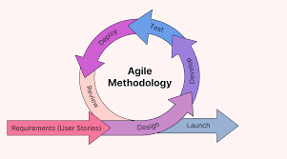

*Fig 3.1 Agile Methodology*

**3.3.1 Interview**

1. Discussions played a crucial role in advancing this project, providing in-depth viewpoints from experts in healthcare. The main aims of the interviews conducted for this initiative are:
2. To gain an understanding of the existing methods used for brain tumor detection, encompassing the current tools and technologies.
3. To collect insights regarding the challenges encountered by healthcare professionals, including the limitations of present technologies and potential areas where machine learning could enhance diagnostic procedures.
4. To investigate user expectations to ensure that the machine learning solution meets the requirements of healthcare providers.

**3.4 Tools and Techniques**

The project employs a range of tools to improve system development and performance. Flask serves as the backend framework, offering a minimalist platform to merge Python with web technologies and develop RESTful APIs, which is crucial for swift iterations in a research-focused setting. The user interface is crafted with HTML and CSS, ensuring a simple experience for healthcare professionals to engage with the system, upload MRI scans, examine results, and access reports. Kaggle acts as the primary storage for datasets, providing high-quality MRI images necessary for training and validating machine learning models. TensorFlow is utilized for image processing and for training deep learning models, harnessing its capabilities to construct and refine Convolutional Neural Networks (CNNs). Seaborn and Matplotlib support effective data visualization, displaying training outcomes and performance metrics of the models, including confusion matrices and ROC curves. NumPy plays a key role in handling large multi-dimensional arrays and matrices, aiding in the preprocessing of image data to ensure efficient and effective manipulation for the machine learning models.

**Dataset used:**

The dataset utilized for this project is compiled from three different datasets obtained from Kaggle:

1. Figshare ()
2. SARTAJ dataset()
3. Br35H()

This dataset contains 7,023 MRI scans of the human brain, organized into four categories: glioma, meningioma, no tumor, and pituitary.

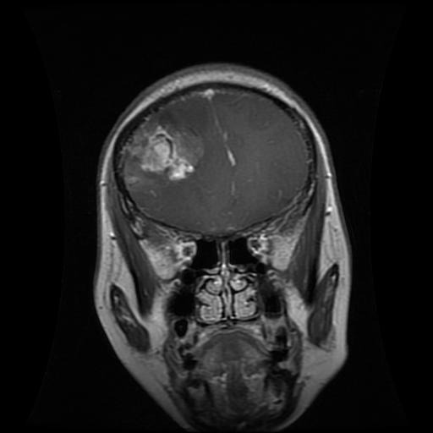

*Fig 3.2 Giloma*

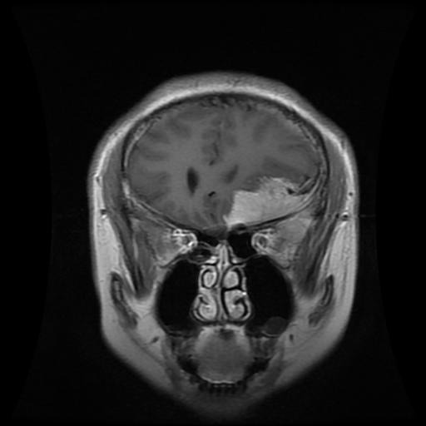

*Fig 3.3 Meningioma*

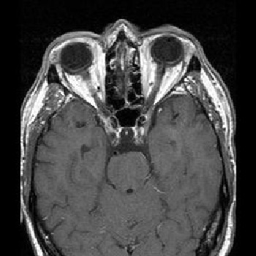

*Fig 3.4 No Tumor*

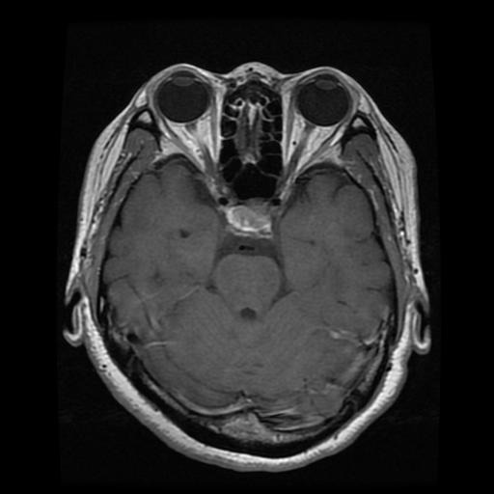

*Fig 3.5 Pituitary*

**Training Techniques**

The project begins with data preparation, organizing MRI images into distinct folders for both training and testing, sorted by tumor types such as glioma, meningioma, and pituitary, along with samples without tumors. To enhance the model's resilience, data augmentation techniques are applied through ImageDataGenerator, which performs a variety of transformations like rotation, flipping, and zooming to artificially expand the dataset and improve generalization.

At the heart of the system is a deep learning model constructed as a Sequential model using platforms such as TensorFlow. This model architecture consists of multiple layers, including convolutional layers for feature extraction, pooling layers to reduce dimensionality, flatten layers to prepare the data for fully connected layers, dropout layers to prevent overfitting, and dense layers for the final classification.

Subsequently, the model is compiled with thoughtfully chosen optimizers and a suitable loss function, such as categorical cross-entropy. Training is conducted using the fit() and fit_generator() methods, which enable the model to learn from the augmented training data over several epochs. Key hyperparameters like batch size, learning rate, and the number of epochs are fine-tuned to achieve optimal performance. Throughout this process, the model gradually improves its ability to accurately detect and classify brain tumors from MRI images.

**3.5 Ethical Considerations**

Ethical considerations are vital for this project, particularly due to the sensitivity of medical data and the potential implications of employing machine learning technologies in healthcare. This section outlines the key ethical issues that must be addressed throughout the project lifecycle, ensuring that development adheres to ethical standards and builds trust with users.

1. The project underscores the significance of safeguarding patient privacy by executing the anonymization of patient data, ensuring that all identifying characteristics are removed from MRI images and their associated metadata to protect individual identities.

2. Gaining informed consent from participants is essential when gathering data for research purposes.

3. To reduce biases in machine learning models, efforts will be directed toward utilizing diverse datasets that reflect different demographic groups (e.g., age, gender, ethnicity) to guarantee fairness in predictions. Furthermore, bias evaluations will be conducted regularly to assess model performance across demographic categories, with corrective measures such as re-sampling or parameter adjustments implemented as necessary when biases are identified.

4. An established feedback system will enable healthcare providers to report any discrepancies between model predictions and clinical outcomes, facilitating continuous model enhancement and ensuring accountability.

5. The system will be incorporated into clinical settings through training for healthcare staff, ongoing performance assessments, and careful integration into current workflows to improve diagnostics while maintaining established practices.

6. As artificial intelligence becomes more embedded in healthcare, ethical issues regarding its application remain a significant concern.

**3.6 Requirement Analysis**

**3.6.1 Hardware Requirements**

1. i5 intel 8th Gen Processor
2. 8 GB RAM
3. 1 TB Hard Disk
4. 4 GB Nvidia GPU
5. Monitor

**3.6.2 Software Requirements**

1. Windows 10
2. Web Browser
3. Python Package Manager
4. IDE (Visual Studio)

**3.7 Requirements Specifications**

**3.7.1 Functional Requirements**

*Table 3.1 Functional Requirements*

| **Requirement Number** | **Description** |
| --- | --- |
| FR-1 | The system should process MRI and CT images to identify potential brain tumors. |
| FR-2 | The model should detect and classify tumors into categories (e.g., benign, malignant). |
| FR-3 | The system must provide an easy-to-use interface for healthcare professionals to submit images and access outcomes. |
| FR-4 | The system should generate comprehensive reports detailing findings, including images and annotations. |

**3.7.2 Non** **Functional Requirements**

*Table 3.2 Non-Functional Requirements*

| **Requirement Number** | **Description** |
| --- | --- |
| NFR-1 | The system should ensure high availability, with uptime of 99.9% to support continuous clinical use. |
| NFR-2 | The system should process images and provide results within 5 minutes to meet clinical needs. |
| NFR-3 | The interface of the system should be user-friendly, enabling users to easily navigate and use the system with little to no training required. |
| NFR-4 | The system must adhere to data protection laws to maintain patient confidentiality. |
| NFR-5 | The system should maintain a response time of less than 2 seconds for user interactions. |
| NFR-6 | The system needs to be able to grow in capacity to accommodate larger data sizes as more images are dealt with. |
| NFR-7 | The system needs to maintain comprehensive records of all interactions to ensure auditing and compliance. |
| NFR-9 | The model should ensure high accuracy rates (above 90%) in tumor detection across diverse datasets. |

**3.8 System Design**

The system architecture for this model is organized to facilitate a smooth collaboration of multiple components that collectively contribute to precise tumor identification. In concert, these elements create a cohesive framework intended to support medical practitioners in identifying brain tumors with a high degree of accuracy, while also ensuring that the system is easy to use and dependable for clinical applications.

**3.8.1 System Architecture**

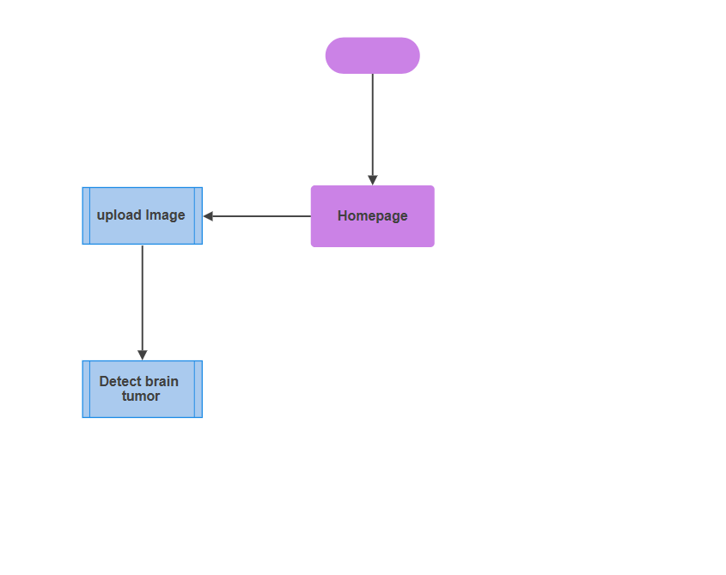

*Fig 3.6 System Architecture*

**3.8.2 Use Case**

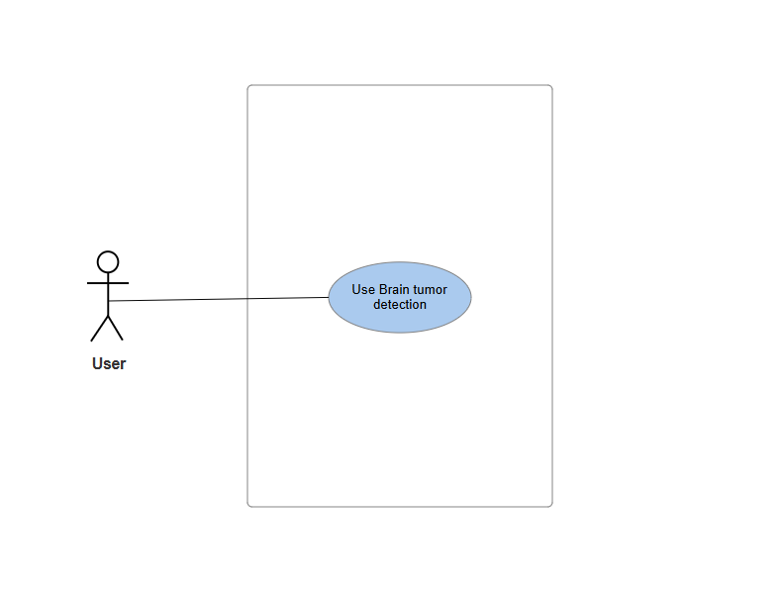

*Fig 3.7 Use Case diagram*

**Use Case: Brain Tumor Detection**

*Table 3.3 Use case description*

| **Attribute** | **Description** |
| --- | --- |
| **Use Case Name** | Brain Tumor Detection |
| **Description** | This use case outlines the process by which the system identifies a brain tumor from an MRI image that has been uploaded, employing machine learning models. |
| **Actors** | - User: Medical professionals or patients uploading MRI images for tumor detection.  - System: Machine learning model integrated into the web app for brain tumor detection. |
| **Preconditions** | 1. The user must be logged into the web application.  2. The user has an MRI image of the brain available for upload.  3. The machine learning model is deployed and integrated with the system. |
| **Postconditions** | The system displays the result of the tumor detection, including whether a tumor is present and the type of tumor (if applicable). |
| **Main Flow** | **User**:  1. The scenario starts when the user submits a brain MRI image to the system. |
| **System** | 1. The system processes the uploaded MRI image using the pre-trained machine learning model.  2. The system analyzes the image to detect any tumors present.  3. The system provides the detection results, including whether a tumor is present, and classification. 4. The system displays the result on the user interface, along with confidence levels. |
| **Exception Condition** | **“No Tumor Detected”**: If no tumor is detected in the MRI image, the system displays a message: "No tumor detected in the MRI image."  **“Error in Detection”**: If the system fails to process the image or encounters an error, it displays an error message: "Error in tumor detection. Please upload a valid MRI image." |
| **Alternative Flow** | 1. If the MRI image provided is in an incorrect format, the system will ask the user to upload a valid image file (such as JPG or PNG).  2. If the system fails to identify any tumors, the user has the option to upload another image or seek further evaluation from a medical professional. |

**3.8.3 Dataflow Diagram**

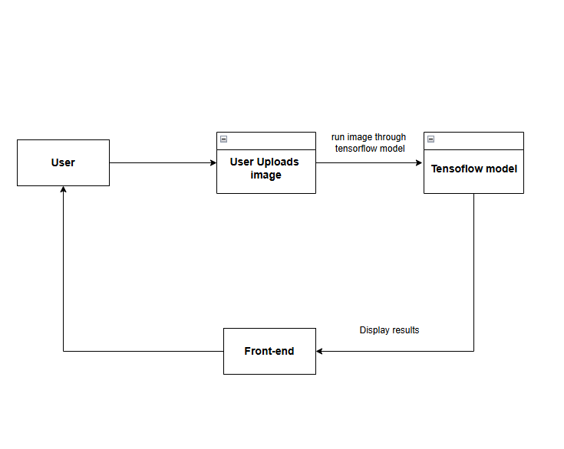

*Fig 3.8 Data flow diagram*

**3.8.4 Activity Diagram:**

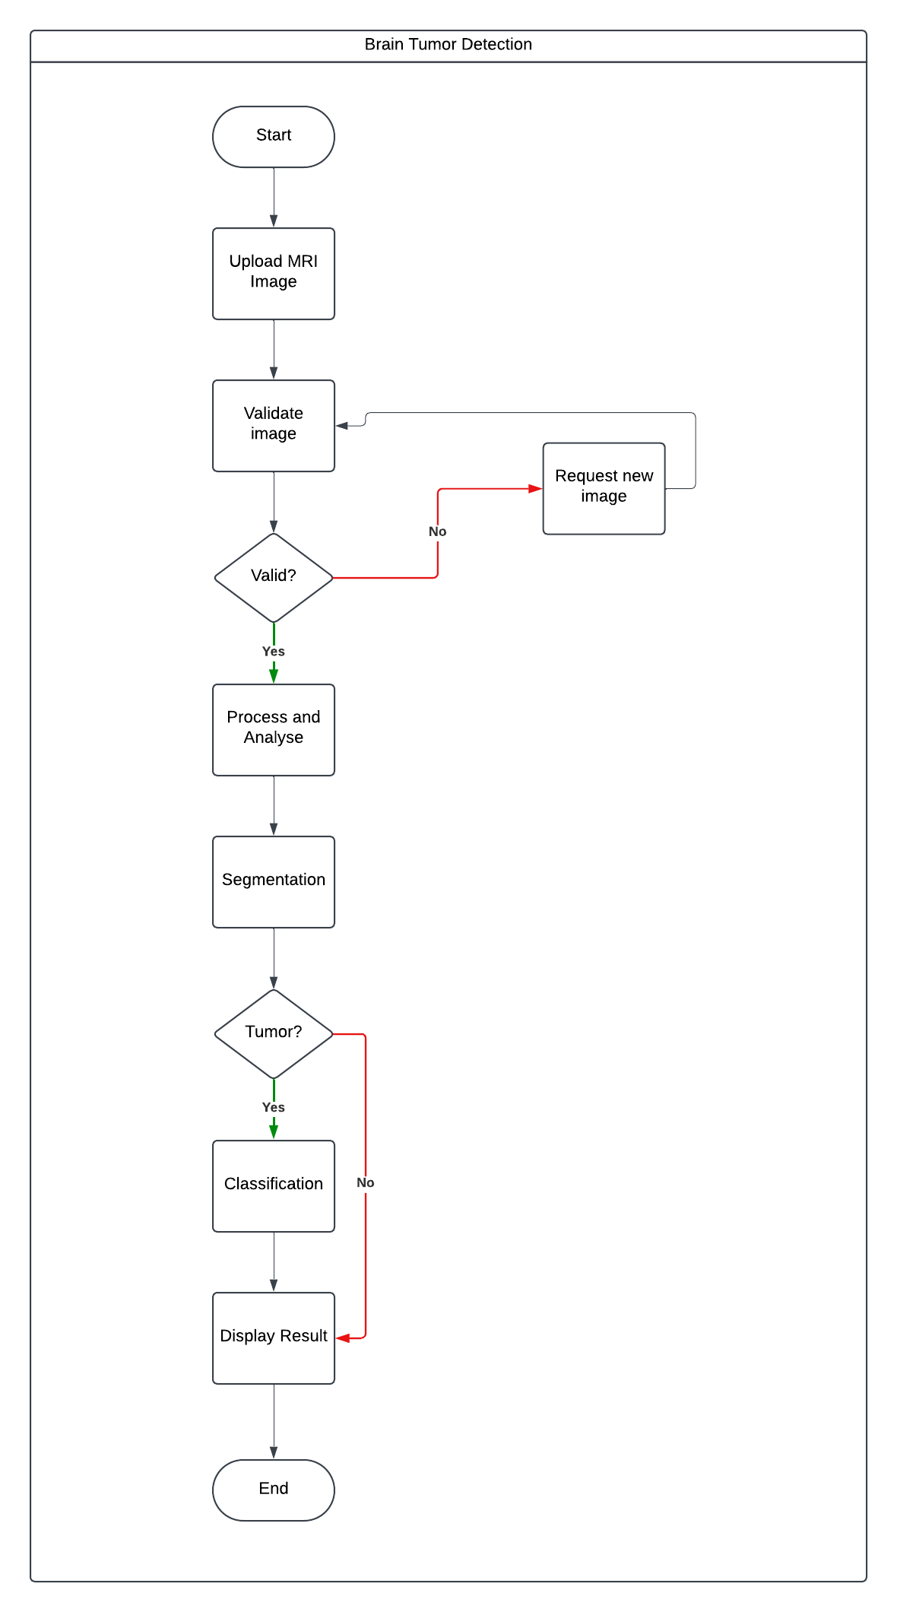

*Fig 3.9 Activity diagram*

**3.8.5 User Interface**

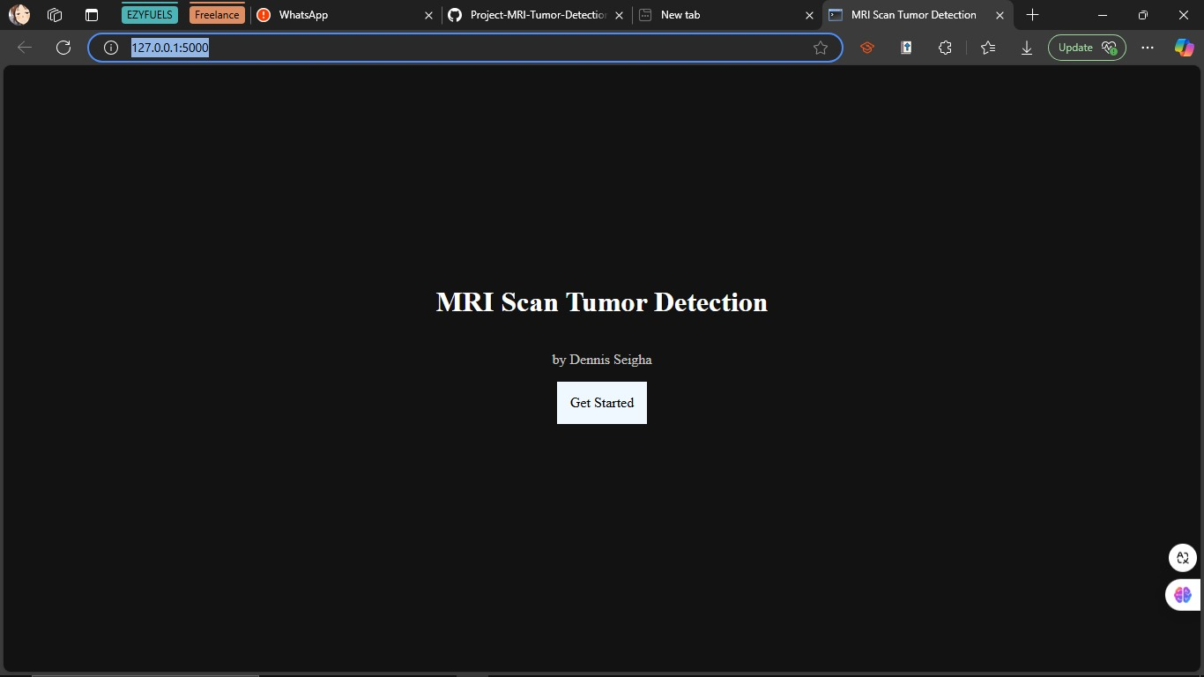

*Fig 3.10 UI 1*

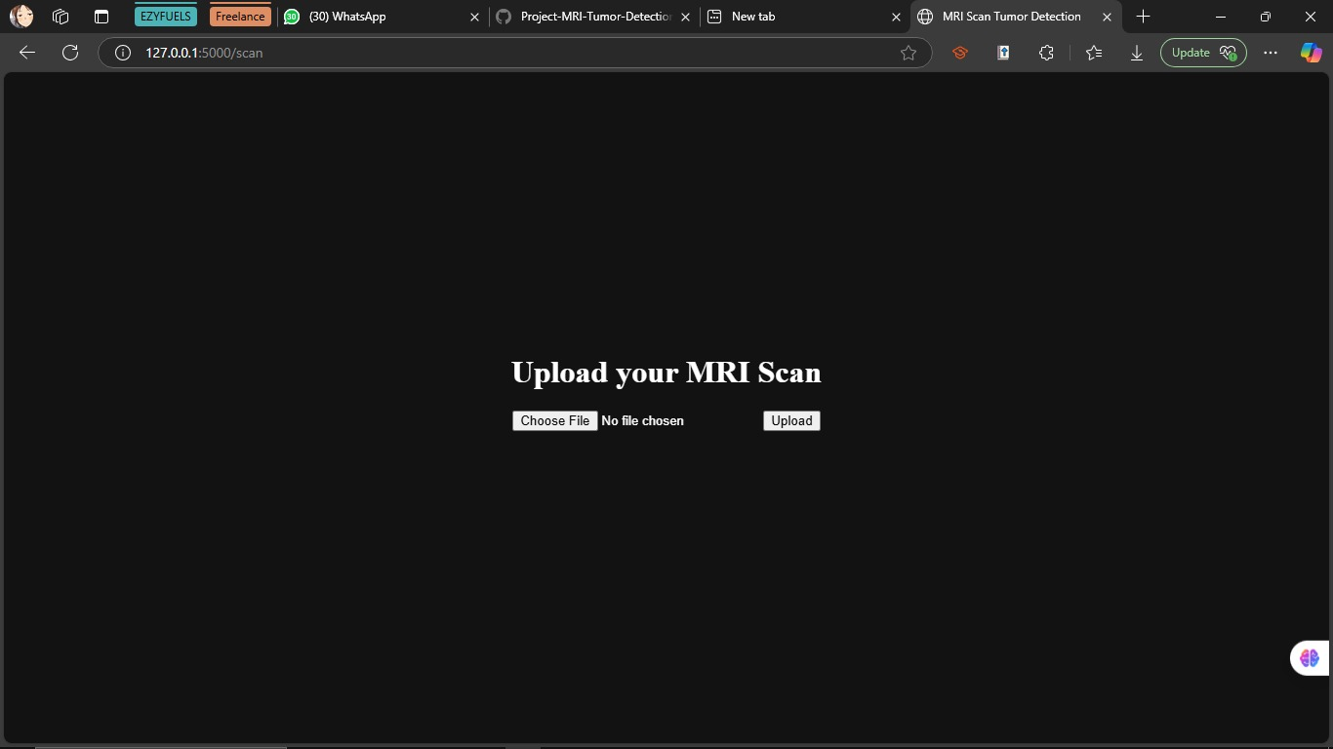

*Fig 3.11 UI 2*

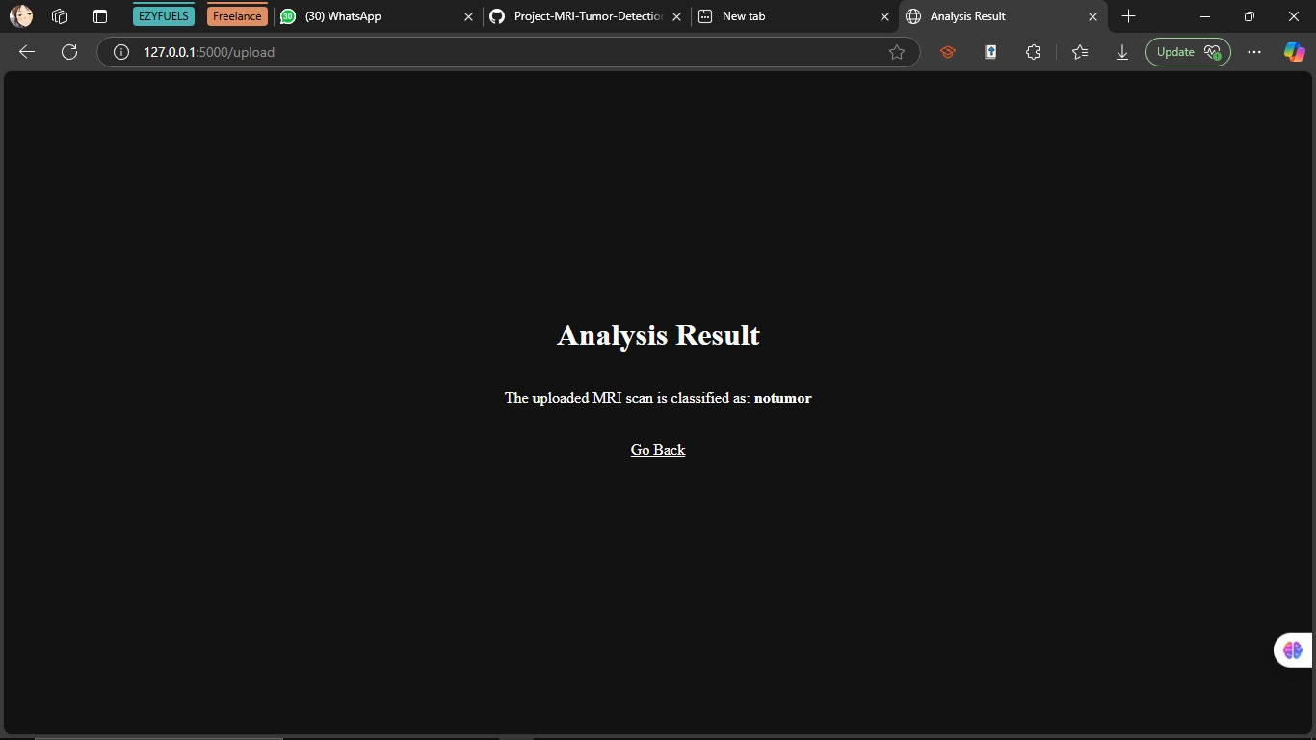

*Fig 3.12 UI 2*

**CHAPTER FOUR**

**IMPLEMENTATION AND TESTING**

**4.1 Overview**

The implementation phase of the Brain Tumor Detection Using Machine Learning project aimed to turn the design specifications into a functional system. This phase included data preparation, model development, training, and the integration of an intuitive user interface. The testing phase rigorously evaluated the system’s performance, accuracy, and usability to ensure it met the objectives of the project, while also offering a user manual for navigating the system.

**4.2 Main Features**

1. Image Processing and Enhancement:
   * The project used Implemented advanced preprocessing techniques to improve MRI image quality.
   * Utilized contrast enhancement and noise reduction algorithms to highlight tumor regions.
2. Deep Learning Model:

• Designed a convolutional neural network (CNN) framework tailored for the detection of brain tumors.

1. Multi-class Classification:

• Facilitated the system's ability to categorize tumors into various types (e.g., glioma, meningioma, pituitary).User Interface:

* + Created an intuitive web-based interface for clinicians to upload MRI scans and view results.
  + Integrated visualization tools to highlight detected tumor regions on the original image.

**4.3 IMPLEMENTATION PROBLEMS**

1. Data Scarcity and Imbalance:
   * Limited availability of high-quality, labeled MRI datasets for rare tumor types.
   * Uneven distribution of samples across different tumor categories.
2. Integration Challenges:
   * Difficulties in seamlessly integrating the machine learning model with the user interface.

**4.4 Overcoming Implementation Problems**

1. Addressing Data Issues:
   * We gathered dataset from multiple sources
   * We applied data augmentation methods to artificially increase the size of the dataset.
   * Utilized transfer learning to leverage knowledge from larger, related datasets.

**4.5 TESTING**

The test plans for the brain tumor detection system utilizing machine learning detail the testing objectives and designate the essential components that need assessment. The main aim is to verify that all important features, including image preprocessing, tumor identification, and classification, are properly integrated and that the application operates as a unified whole.

**4.5.1 Test Plans**

*Table* 4.1 Test cases summary

|  |  |  |  |  |  |  |
| --- | --- | --- | --- | --- | --- | --- |
| **Test Type** | **Test Case** | **Description** | **Input** | **Process** | **Expected Output** | **Assertion** |
| Unit Testing | Model Prediction | Validate tumor classification | Pre-processed MRI image of known tumor | Feed image to trained model | Correct tumor classification | Predicted class matches known type |

|  |  |  |  |  |  |  |
| --- | --- | --- | --- | --- | --- | --- |
| Integration Testing | Image Processing Pipeline | Test end-to-end workflow | Raw MRI image file | Preprocess → Model prediction | Predicted Result | Each step executes without errors, final result accurate |
| Integration Testing | UI-Backend Integration | Verify user upload and result display | User uploads image via web interface | Frontend → Backend processing → Frontend display | Results displayed on UI | Correct results shown within 10 seconds of upload |
| System Testing | Accuracy Evaluation | Measure overall system accuracy | Large, diverse test dataset (500+ images) | Process entire dataset through system | High accuracy across all tumor types | Overall accuracy > 95%, F1-score > 0.90 for each class |
| System Testing | Cross-platform Compatibility | Check system on different browsers/devices | Utilize the system through Chrome, Firefox, or Safari on both desktop. | Perform standard workflow on each platform | Consistent functionality across platforms | All features work correctly on each tested platform |

**4.6 Results**

After system testing was done which included using a variety of new MRI images and it performed well, the following results were collated;

Accuracy: The accuracy ranged from 90% to 100% for the training set and between 85% and 90% for the validation set, as illustrated below:

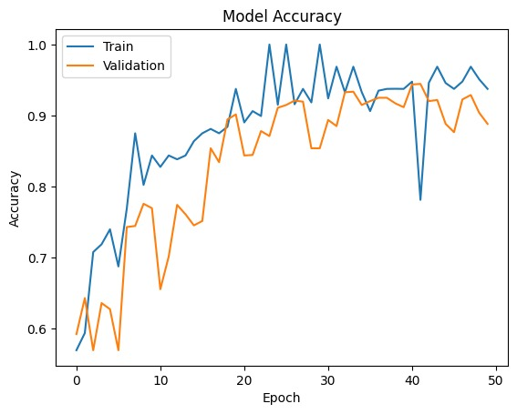

*Fig 4.1 Model Accuracy*

Model Loss: The Training loss was just below 0.2 and the Validation loss around 0.3 as shown below.

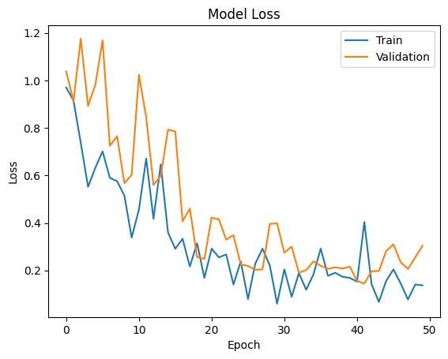

*Fig 4.2 Model Loss*

Confusion Matrix: The model performs well overall, particularly in the notumor category, with 403 true positives and minimal misclassification, as only 2 instances are predicted as glioma. Glioma and pituitary tumors are also classified effectively, with few misclassifications. However, the model struggles most with meningioma, where it is often confused with other tumor types, particularly glioma and notumor. Additionally, there are some false negatives for meningiomas (52) and pituitary tumors (2), indicating that there is potential for better accuracy in identifying these categories.

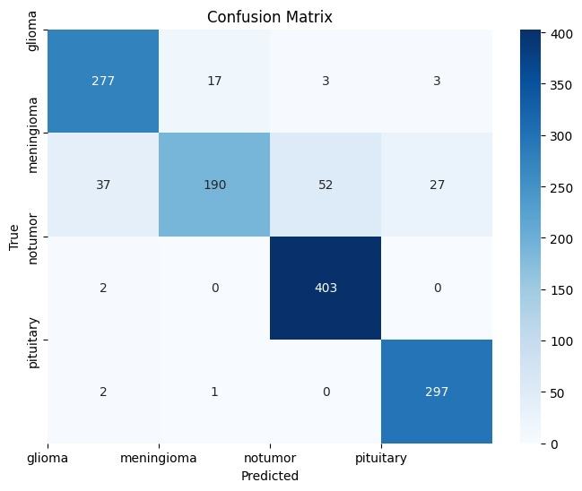

*Fig 4.3 confusion matrix*

For the Recall, Precision and F1scores;

*Table 4.1 Model scores*

| **Class** | **Precision (%)** | **Recall (%)** | **F1-Score (%)** |
| --- | --- | --- | --- |
| Glioma | 87.11 | 92.33 | 89.64 |
| Meningioma | 91.35 | 62.09 | 73.93 |
| No Tumor | 87.99 | 99.51 | 93.40 |
| Pituitary | 90.83 | 99.00 | 94.74 |

**4.7 User Guide**

**1. Accessing the Web Application:**

* Open the web application in your preferred browser by visiting the provided URL.

**2. Uploading MRI Images:**

i. **Home Screen**:

* The home screen will display a simple interface for uploading your MRI images for analysis.  
  ii. **Upload Image**:
* Click the **Upload Image** button on the home page.
* Select the MRI image file from your computer. Supported formats: JPG, PNG, and DICOM.  
  iii. **Upload**:
* After selecting your image, click the **Upload** button to start the analysis process.

**3. Viewing the Analysis Results:**

* Once the image is uploaded, the model will analyze the MRI scan and return a classification.
* The result will show whether the image is classified as:
  + **Glioma**
  + **Meningioma**
  + **Pituitary Tumor**
  + **No Tumor**

1. **Repeat the Process:** You can upload additional MRI images by returning to the **Home Screen** and repeating the upload process.

**4.8 Summary**

The implementation stage of the Brain Tumor Detection Using Machine Learning project focused on converting the design specifications into a working system. This stage encompassed data preparation, model creation, training, and the integration of an easy-to-use interface. The testing stage thoroughly assessed the system’s performance, accuracy, and usability to guarantee it fulfilled the project goals, while also providing a user manual for operating the system.

**CHAPTER FIVE**

**DISCUSSIONS AND RECOMMENDATIONS**

**5.1 OVERVIEW**

This chapter presents a comprehensive evaluation of the outcomes from the brain tumor detection initiative, examining the objectives achieved, identifying the limitations and challenges faced throughout the process, proposing possible enhancements, and offering suggestions for further research and development. The insights gained from this project contribute to the continuous efforts to improve diagnostic accuracy and efficiency in clinical settings.

**5.2 OBJECTIVE ASSESSMENT**

The main goals of this project were to create a machine learning-based system that can effectively identify and categorize brain tumors using MRI scans. The system accomplished impressive accuracy levels across various tumor classifications, showcasing efficient preprocessing methods and strong model performance. Essential performance indicators like precision, recall, and F1-score suggest that the system can consistently support healthcare professionals in diagnosing brain tumors, thereby improving decision-making in the medical field.

**5.3 LIMITATIONS AND CHALLENGES**

Although this project achieved several successes, it faced a number of limitations and challenges.

1. **Data Limitations**: The availability of high-quality, labeled datasets for rare tumor types was limited.
2. **Model Complexity**: The deep learning model's complexity required significant computational resources for training and inference, which could be a barrier in resource-constrained environments.
3. **Integration Issues**: Initial plans for a mobile application faced compatibility issues with the model format, leading to a shift toward a web-based solution.
4. **Overfitting Risks**: Although measures were taken to mitigate overfitting, there remains a risk that the model may not perform well on unseen data.

**5.4 FUTURE ENHANCEMENTS**

To tackle the identified limitations and enhance the system's functionalities, some upgrades are suggested:

1. **Data Augmentation**: Implement more sophisticated data augmentation techniques to artificially expand the dataset and improve model robustness.
2. **Transfer Learning**: Explore additional transfer learning strategies using larger pre-trained models to enhance detection accuracy for rare tumor types.
3. **Real-Time Processing**: Develop optimizations for real-time image processing to facilitate immediate diagnostic feedback in clinical settings.
4. **User Interface Improvements**: Enhance the user interface for better usability and accessibility for clinicians.

**5.5 RECOMMENDATIONS**

Based on the findings from this project, the following recommendations are proposed:

1. **Collaborative Data Sharing**: Encourage collaboration among medical institutions to create larger, more diverse datasets that can improve model training and validation.
2. **Continuous Model Training**: Establish protocols for continuous model training with new data to adapt to evolving diagnostic needs and improve accuracy over time.
3. **Integration with Clinical Workflows**: Work closely with healthcare professionals to ensure that the system integrates seamlessly into existing clinical workflows, enhancing adoption rates.

**5.6 SUMMARY**

To conclude, this chapter has outlined the positive results of the brain tumor detection initiative while recognizing its constraints and obstacles. The initiative has shown that machine learning can play a crucial role in identifying brain tumors from MRI scans, offering a beneficial resource for healthcare professionals. Suggested improvements and future recommendations focused on enhancing data quality, model efficacy, and user engagement will help progress this significant field of medical technology.

**REFERNCES**

Birajdar, M. (2023). Brain Tumor Detection Using Machine Learning with CNN Algorithm. *International Journal for Research in Applied Science and Engineering Technology*, *11*(12), 1099–1102. https://doi.org/10.22214/ijraset.2023.57529

Brindha, P. G., Kavinraj, M., Manivasakam, P., & Prasanth, P. (2021). Brain tumor detection from MRI images using deep learning techniques. *IOP Conference Series Materials Science and Engineering*, *1055*(1), 012115. https://doi.org/10.1088/1757-899x/1055/1/012115

Chauhan, S., Parchure, S., & Scott, J. (2023). Comparing Machine Learning Models to Determine Which is Most Effective at Detecting Brain Tumors. *Journal of Student Research*, *12*(1). https://doi.org/10.47611/jsrhs.v12i1.3999

Ghemosu, D., & Joshi, S. R. (2021). Detection and classification of MRI-Based brain tumor via JAYA algorithm and Twin support vector machine. *Journal of Science and Engineering*, *9*, 31–42. https://doi.org/10.3126/jsce.v9i9.46299

Goyal, D., & Sharma, H. (2023). Brain tumor detection system using neural networks. *International Journal of Communication and Information Technology*, *4*(1), 59–63. https://doi.org/10.33545/2707661x.2023.v4.i1a.61

Hollon, T. C., Lewis, S., Pandian, B., Niknafs, Y. S., Garrard, M. R., Garton, H., Maher, C. O., McFadden, K., Snuderl, M., Lieberman, A. P., Muraszko, K., Camelo-Piragua, S., & Orringer, D. A. (2017). Rapid intraoperative diagnosis of pediatric brain tumors using stimulated Raman histology. *Cancer Research*, *78*(1), 278–289. https://doi.org/10.1158/0008-5472.can-17-1974

Khan, F., Ayoub, S., Gulzar, Y., Majid, M., Reegu, F. A., Mir, M. S., Soomro, A. B., & Elwasila, O. (2023). MRI-Based Effective Ensemble Frameworks for Predicting Human Brain Tumor. *Journal of Imaging*, *9*(8), 163. https://doi.org/10.3390/jimaging9080163

Kumar, V., Krishna, K., & Kusumavathi, S. (2019). An Automated Method for MRI Based Brain Tumor Detection using Berkeley Wavelet Transformation and Support Vector Machine. *International Journal of Engineering and Advanced Technology*, *8*(6s3), 1062–1065. https://doi.org/10.35940/ijeat.f1175.0986s319

Lamrani, D., Cherradi, B., Gannour, O. E., Bouqentar, M. A., & Bahatti, L. (2022). Brain Tumor Detection using MRI Images and Convolutional Neural Network. *International Journal of Advanced Computer Science and Applications*, *13*(7). https://doi.org/10.14569/ijacsa.2022.0130755

Ma, Z., & Lin, Z. (2023). The classification of human brain tumors with machine learning. *Journal of Physics Conference Series*, *2580*(1), 012033. https://doi.org/10.1088/1742-6596/2580/1/012033

Manogaran, G., Shakeel, P. M., Hassanein, A. S., Kumar, P. M., & Babu, G. C. (2018). Machine Learning Approach-Based gamma distribution for brain tumor detection and data sample imbalance analysis. *IEEE Access*, *7*, 12–19. https://doi.org/10.1109/access.2018.2878276

Reszke, M., & Smaga, Ł. (2023). Machine learning methods in the detection of brain tumors. *Biometrical Letters*, *60*(2), 125–148. https://doi.org/10.2478/bile-2023-0009

Sadad, T., Rehman, A., Munir, A., Saba, T., Tariq, U., Ayesha, N., & Abbasi, R. (2021). Brain tumor detection and multi‐classification using advanced deep learning techniques. *Microscopy Research and Technique*, *84*(6), 1296–1308. https://doi.org/10.1002/jemt.23688

Saeedi, S., Rezayi, S., Keshavarz, H., & Kalhori, S. R. N. (2023). MRI-based brain tumor detection using convolutional deep learning methods and chosen machine learning techniques. *BMC Medical Informatics and Decision Making*, *23*(1). https://doi.org/10.1186/s12911-023-02114-6

Sarwar, N., Noreen, I., & Irshad, A. (2022). Development of the Tumor Diagnosis Application for Medical Practitioners using Transfer Learning. *BioScientific Review*, *4*(2), 78–93. https://doi.org/10.32350/bsr.42.05

Shrotriya, L., Agarwal, G., Mishra, K., Mishra, S., Bidwe, R. V., & Kaur, G. (2023). Brain tumor detection using advanced deep learning implementations. *Traitement Du Signal*, *40*(5). https://doi.org/10.18280/ts.400508

Srinivasalu, P., & Palaniappan, A. (2022). Brain tumor detection by modified particle swarm Optimization algorithm and Multi-Support Vector Machine Classifier. *International Journal of Intelligent Engineering and Systems*, *15*(6), 91–100. https://doi.org/10.22266/ijies2022.1231.10

Sutradhar, P., Tarefder, P. K., Prodan, I., Saddi, M. S., & Rozario, V. S. (2021). Multi-Modal Case Study on MRI Brain Tumor Detection Using Support Vector Machine, Random Forest, Decision Tree, K-Nearest Neighbor, Temporal Convolution & Transfer Learning. *AIUB Journal of Science and Engineering (AJSE)*, *20*(3), 107–117. https://doi.org/10.53799/ajse.v20i3.175

Tummala, R. (2023). A novel approach to brain tumor classification using deep neural networks. *medRxiv (Cold Spring Harbor Laboratory)*. https://doi.org/10.1101/2023.10.03.23296522

Wang, J. (2023). The role of machine learning in the detection and classification of brain tumors: A literature review of the past two years. *Computer and Information Science*, *16*(2), 20. https://doi.org/10.5539/cis.v16n2p20

# **Appendix A - Project Document**

**IN-DEPTH PROJECT DOCUMENTATION**

**Full Candidate Name:** Seigha Dennis Junior

**Student ID:** BU/22A/IT/6599

**Title:** Design And Implementation Of A Brain Tumors Detection System Using Machine Learning

**Course of Study:** B.Sc. Computer Science.

**Background and Motivation**

The brain serves as the central command of the human body, and in recent years, a variety of brain disorders have been identified. The tools for diagnosing brain diseases are becoming increasingly complex and remain a significant area for further research; however, the use of AI in diagnosing brain disorders has enhanced the precision and accuracy of disease prediction and identification. Automated methods for the non-invasive examination of brain images have become essential, as brain diseases are often life-threatening and are a major cause of mortality in developed nations. The integration of AI in brain tumor surgery can lead to safer and more effective treatment outcomes. A notable challenge remains the knowledge gap between clinical professionals and data science experts. This project originates from a need for a tool capable of automatically, scalably and cost effectively helping radiologists to detect brain tumors more precisely and in a timely manner resulting in improved patient outcome.

**Statement of the Problem**

The problem statement of this work highlights several critical issues in the detection of brain tumors using MRI scans. First, the accuracy of brain tumor detection is compromised due to the reliance on physicians to manually identify tumors, which not only affects detection accuracy but is also a time-consuming process. Second, tumor segmentation presents significant challenges because of the complex nature of brain structures, making it difficult to delineate tumor boundaries accurately. Finally, the primary challenge lies in identifying brain tumors amidst variations in tumor location, shape, size, and intensity across different patients, coupled with the often unclear and irregular boundaries of the tumors. These factors collectively underscore the need for advanced automated solutions to enhance diagnostic accuracy and efficiency in clinical practice.

# **Appendix B- Source Codes**

